Capstone Project: Why does Kiva “work”?

I have interest in the social entrepreneurship field. I would like to study and look at Kiva.

Why am I interested in this model that produces 97.1% repayment rate?

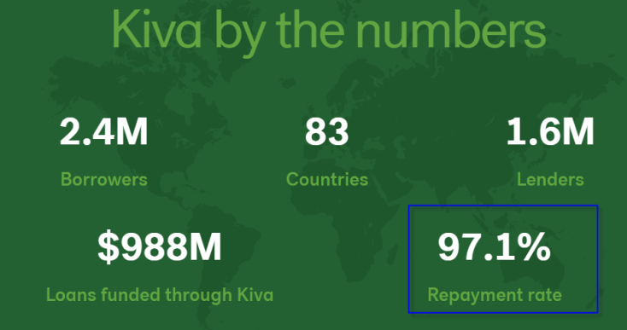

The repayment rate is very impressive that in itself is worth looking at.

However, I start my focus at 3% that don’t get repaid reasons and cause? Is the 97% repayment rate really achievable? What is reason for the success? Does the vetting process very stringent and is that the cause for high repayment success rate? Basically, does Kiva lend money to “good” borrowers? I would like the data to lead me and help me discover the reasons.